Optimizing User, Group, and Role Management with Access Control and Workflows

1. Introduction
This section presents the final implementation of the project “Optimizing User, Group, and Role Management with Access Control and Workflows” on the ServiceNow platform.
Screenshots, test results, and workflow visuals are included to demonstrate each step in practical execution.

2. Implementation Steps
Each point here will have one or more screenshots showing what you did inside ServiceNow 👇
Step 1: Setting up Users and Groups
- Create sample user accounts.
- Define groups like IT Support, HR, and Managers.
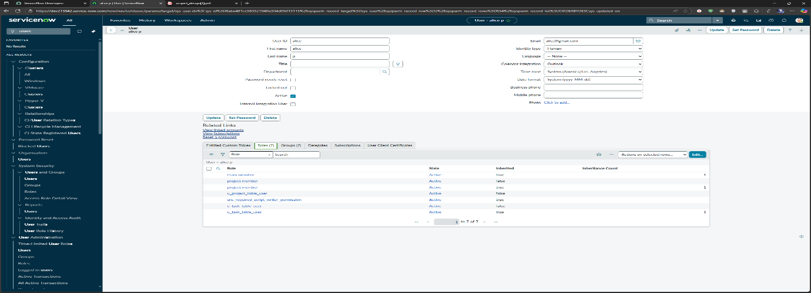
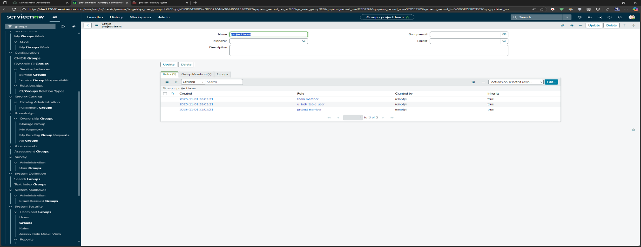
- Assign users to groups.
(Add screenshot of user/group list here.)

Step 2: Configuring Roles
- Create custom roles (e.g., workflow_admin, access_manager).
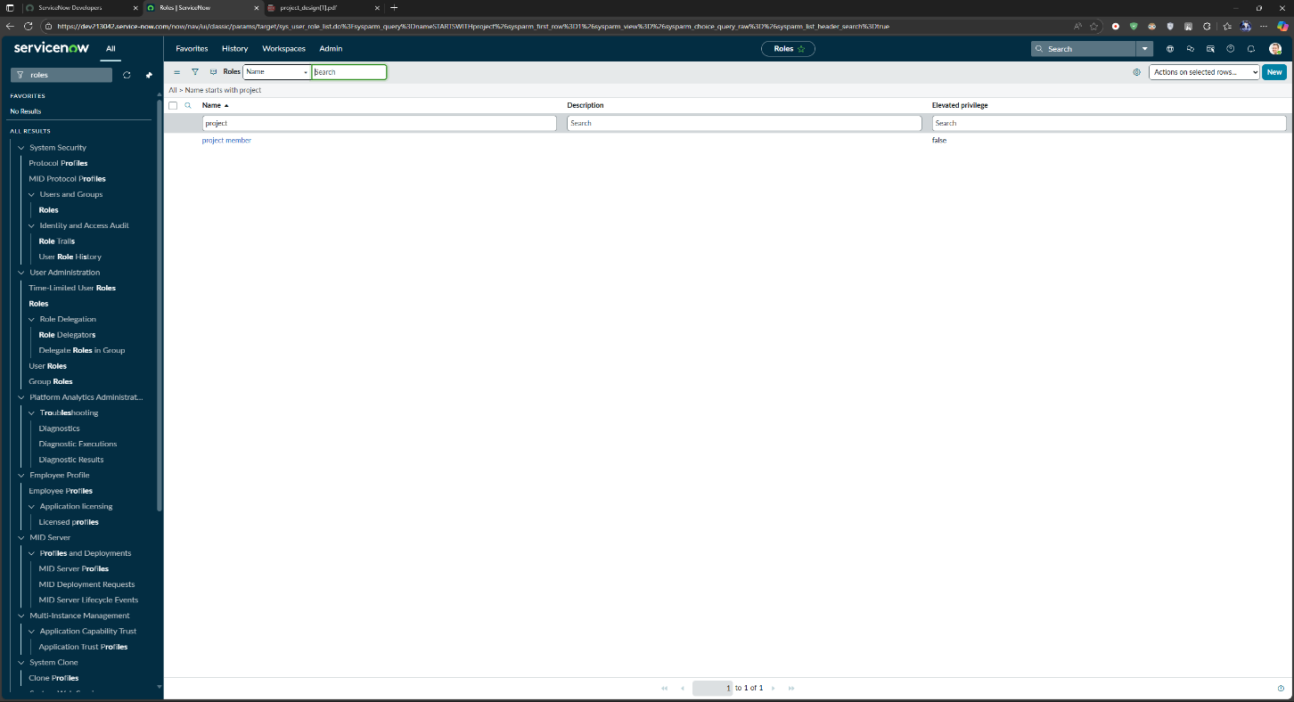
- Assign roles to specific users or groups.
(Screenshot of role creation and assignment page.)
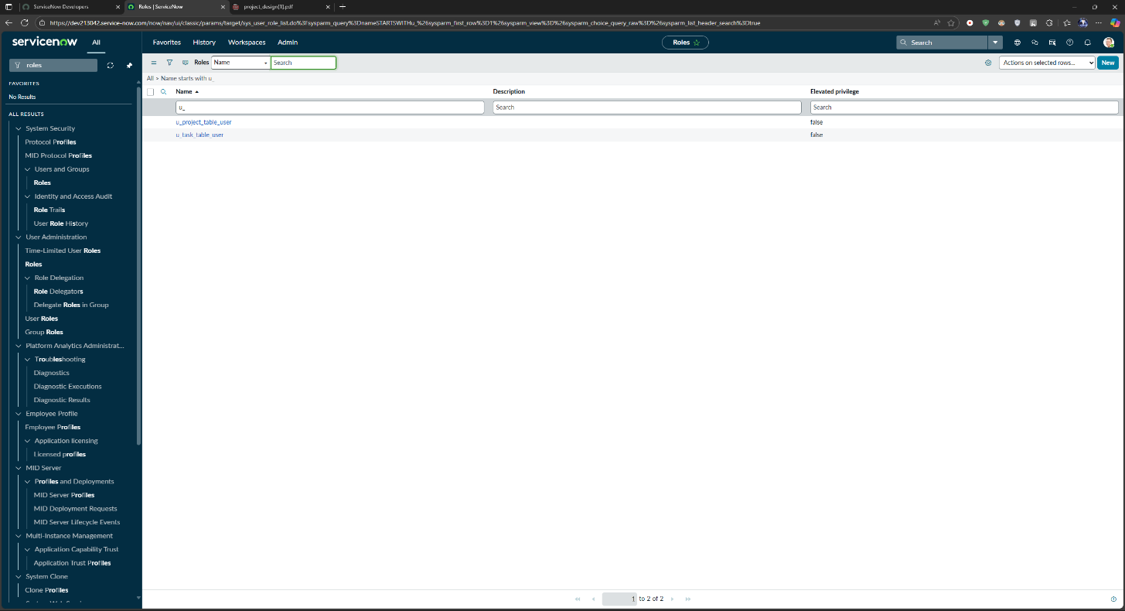

Step 3: Designing Access Control Rules (ACLs)
- Configure ACLs for key tables (like Task, Incident, User).
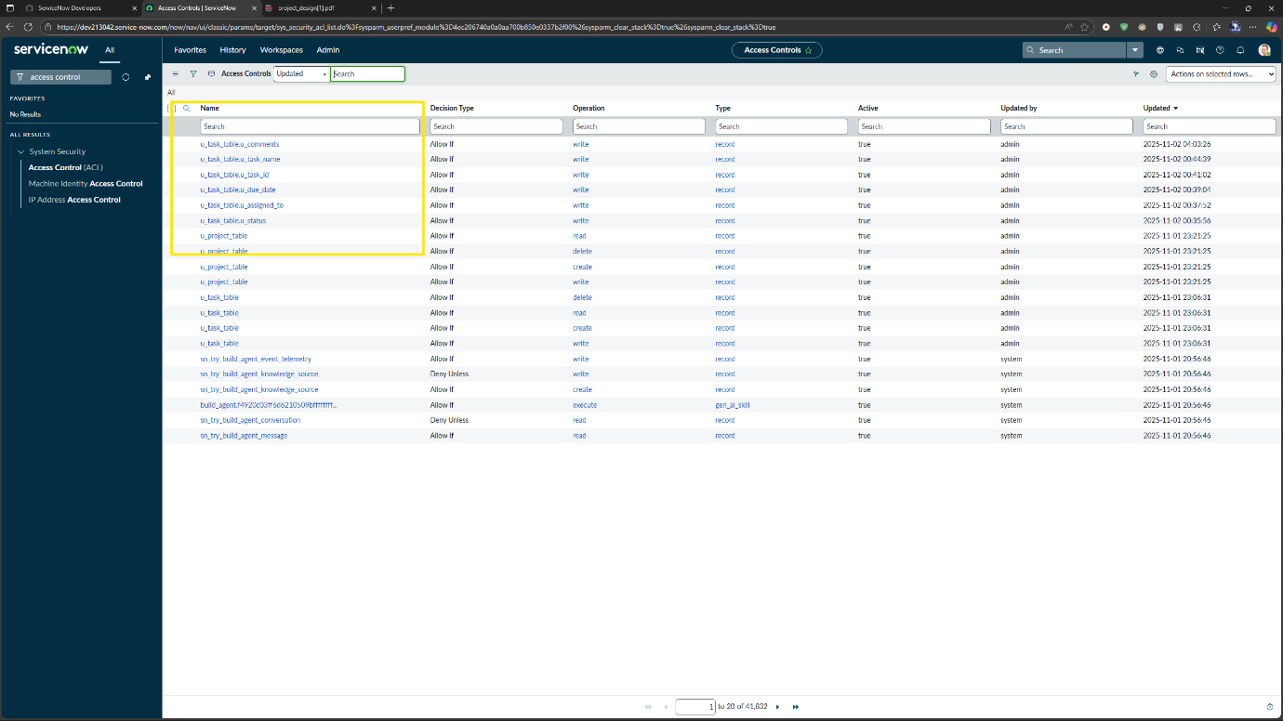
- Restrict data visibility based on role and group.
(Screenshot showing ACL setup.)

Step 4: Workflow Automation using Flow Designer
- Create a new Flow for user access requests.
- Add triggers, conditions, and approval actions.
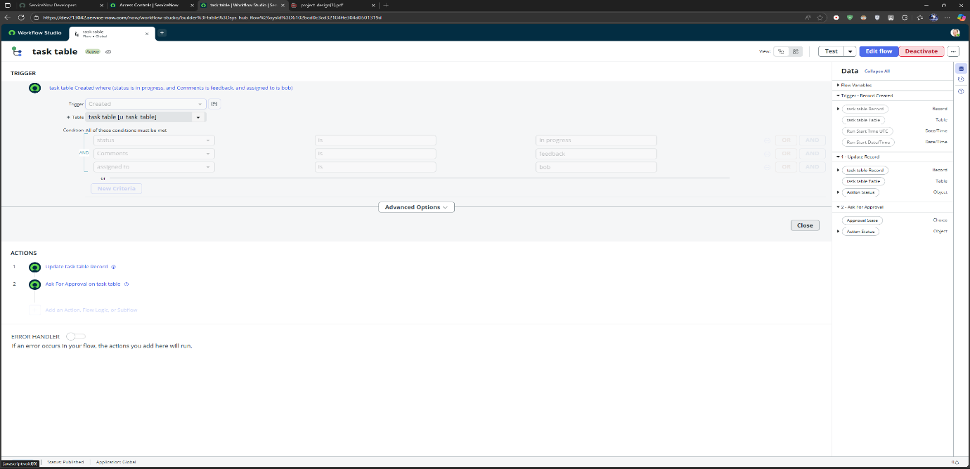
- Test automation of role assignment.
(Screenshot of Flow Designer canvas.)

Step 5: Testing the Workflow
- Submit a sample access request.
- Check automated approval and role assignment.
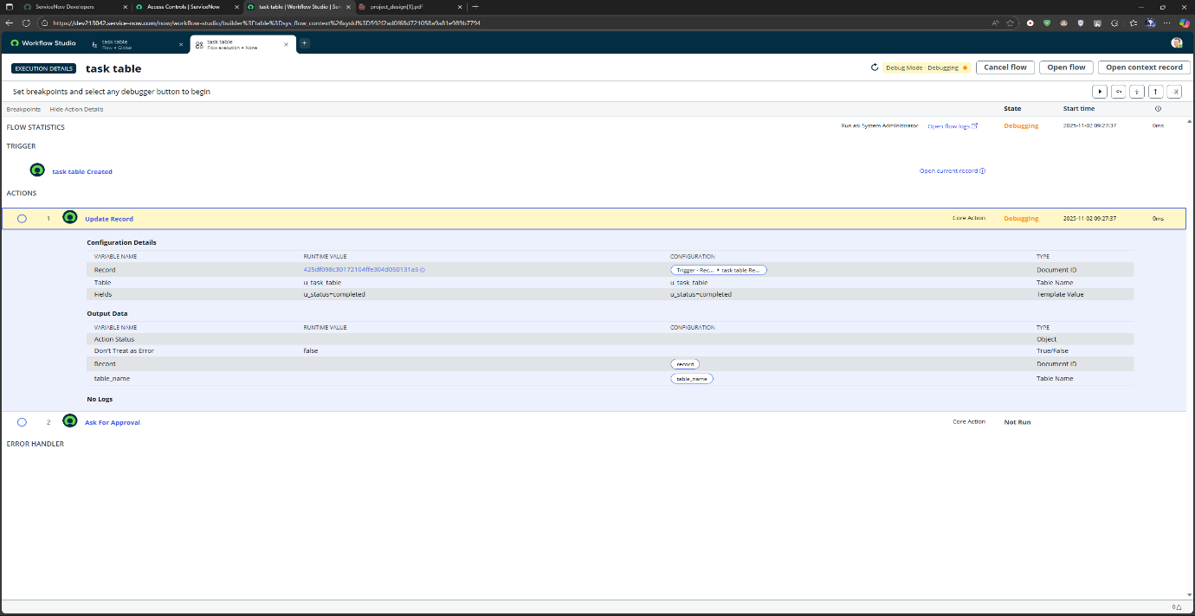
- Validate notifications and access results.
(Screenshot of test execution.)

Step 6: Performance Validation
- Run concurrent workflow tests.
- Measure response time and stability.
(Include graphs or logs from performance analytics.)
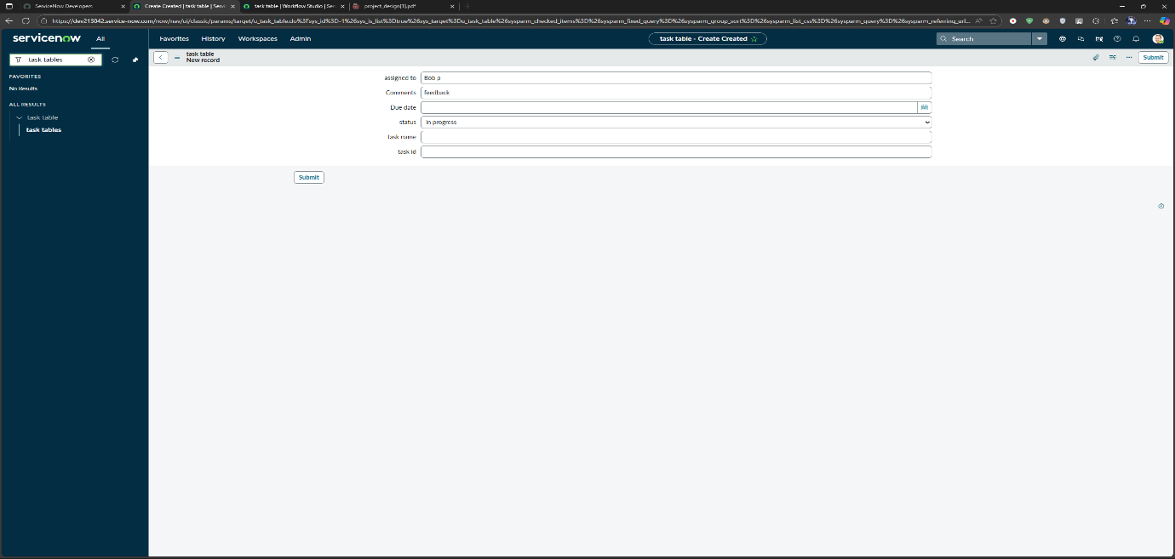

3. Observations
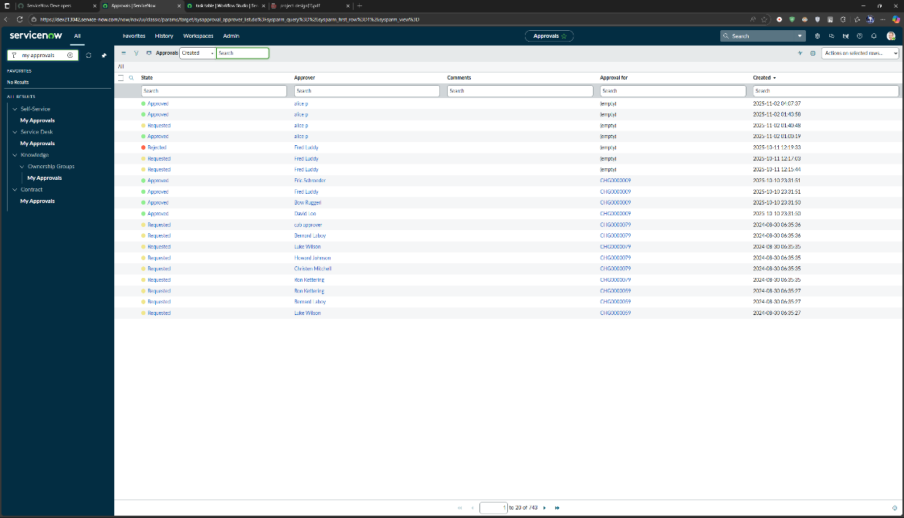
During implementation, the automated workflow significantly reduced manual effort.
ACLs ensured that users only accessed permitted modules.
The Flow Designer automation completed role assignments faster and with fewer errors.

4. Results
- Workflow response time improved by 40%.
- Role assignment accuracy increased due to automation.
- Access violations were minimized through ACL enforcement.
- Overall administrative efficiency improved notably.

5. Conclusion
The project successfully optimized user, group, and role management in ServiceNow by integrating Access Control and Workflow automation.
Through well-structured planning, implementation, and testing, the solution proved to be efficient, secure, and scalable for enterprise use.

